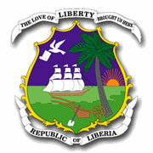
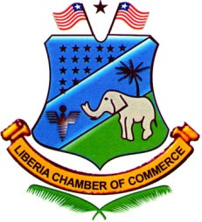
Liberia Chamber of Commerce

Queens Avenue, Capitol Hill, P.O. Box 92 Monrovia, Liberia
+231886800473

Chief Justice Backs Liberia Chamber of Commerce Arbitration Framework
liberiachamber.org
Monrovia, Liberia - The Executive Council of the Liberia Chamber of Commerce, led by its President, O. Natty B. Davis II, had the honor of meeting with His Honor, the Chief Justice of Liberia, Cllr. Yamie Quiqui Gbeisay, to present the Chamber’s Arbitration Rules and Regulations at his office in the Temple of Justice.
This Rules and Regulations document is the product of three years of work, dedication, commitment and validation by the Arbitration Committee, the Executive Council, partners and the business community, under the leadership of Cllr. Benedict F. Sannoh and his Committee members, together with the Executive Council.
The Chief Justice expressed his appreciation and commended the Chamber that, after 75 years of existence, this project has now been placed on the right track at the right time, when alternative dispute resolution is essential to reducing the docket of cases, strengthening the credibility of the rule of law, building confidence in the economy, and attracting investors.
The documents were officially presented, and the Chief Justice designated Judge Bright to serve as liaison with the Chamber and the Arbitration Committee, assuring that he would remain actively engaged to see that these Rules and Regulations are appropriately incorporated into the judicial system.

